SEWP VI Ordering Guide

SEWP Overview
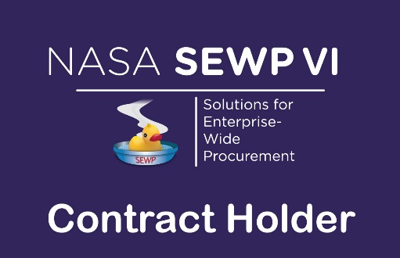
NASA’s Solutions for Enterprise-Wide Procurement VI (SEWP VI) provides the latest Information Technology, Communication, and Audio-Visual (ITC/AV) solutions and services for all Federal Agencies and their approved contractors. Created in 1993, SEWP I was the first Government-Wide Acquisition Contract (GWAC) in the federal acquisition space.

Credence Contract #: 80TECH26D1860

SEWP VI Category:
Category B: Enterprise-Wide IT
Service Solutions

Period of Performance:
11/1/2026 - 10/31/2036

Contract Fee: 0.34%

SEWP VI Program Support:
Amy Anda
Program Manager
aanda-sewp@credence-llc.com

Dylan Panzer
Deputy Program Manager
dpanzer-sewp@credence-llc.com

More Information

SEWP VI Helpline
help@sewp.nasa.gov
(301) 286-1478

SEWP PMO Hours:
M-F, 7:30 AM – 6 PM (ET)

SEWP VI Website
www.sewp.nasa.gov

Originally, the contract vehicle provided only technology products for NASA. SEWP has continually evolved over the past 30 years, expanding its scope to meet the requests of its customers. The SEWP IV contract vehicle represents acquisition innovation within the Federal Government. The program is self-funded through usage fees (0.34%) and provides all Federal agencies with acquisition
support.

Fair Opportunity
The FAR states that the method to obtain fair opportunity is at the discretion of the Contracting Officer (CO) and that the CO must document the rationale for placement and price of each order. Using the SEWP online Quote Request Tool is the recommended method to assist in this activity and to augment the required decision documentation. The SEWP Quote Request Tool (QRT) will automatically include the Contract Holders within a selected Group or based on a suggested source.

What is in Scope for SEWP VI
SEWP is designed to provide a broad suite of Information Technology, Communication and Audio Visual (ITC/AV) solutions and services. Technology is ever evolving and for that reason SEWP's processes enable our Contract Holders to add new commercial technology and IT services to their contract daily, as requested by our customers. The focus of SEWP is on the full suite of technology offerings that simplify Governmental access and Industry offerings across the entire ITC/AV solutions and services landscape.

SEWP is composed of three (3) scope categories detailed below. If you would like SEWP to determine if your requirement is within scope of the SEWP VI contract, please send an overview and/or bill of materials (BOM) to help@sewp.nasa.gov and they will quickly review and provide feedback.

The SEWP Contracts are awarded by scope category. The three categories are:
- Category A – ITC/AV Solutions
- Category B – Enterprise-Wide ITC/AV Service Solutions
- Category C – Mission-Based ITC/AV Service Solutions

Ordering Process
The internal ordering process of each Agency varies. The process and accompanying forms for Purchase Requests (PR) and Delivery Orders (DO) that are issued against a SEWP contract are defined by the issuing agency, not by the NASA SEWP Program Management Office (PMO).

The typical process is for an end-user to determine a requirement and generate a PR. The PR along with any necessary funding information is sent to that agency’s procurement office which results in the issuance of a DO. Any valid Federal Agency DO form, and the associated DO number may be used. The NASA SEWP PMO does not issue DOs – these must be issued through the issuing agency’s procurement office.

The SEWP PMO reviews, processes, and tracks issued DOs and forwards them to the Contract Holder(s). Some Agencies have special requirements for issuing IT Delivery Orders. It is the Issuing Agency's Contracting Officer’s responsibility to be aware of any agency-specific policies regarding issuing orders via an existing contract vehicle and Government-Wide Acquisition Contracts. There are no requirements under the SEWP Contracts for issuing Agencies to use other intermediary procurement offices, except as directed through their own internal policies.

If modifications are made to any order, these modifications must also route through the SEWP PMO.

